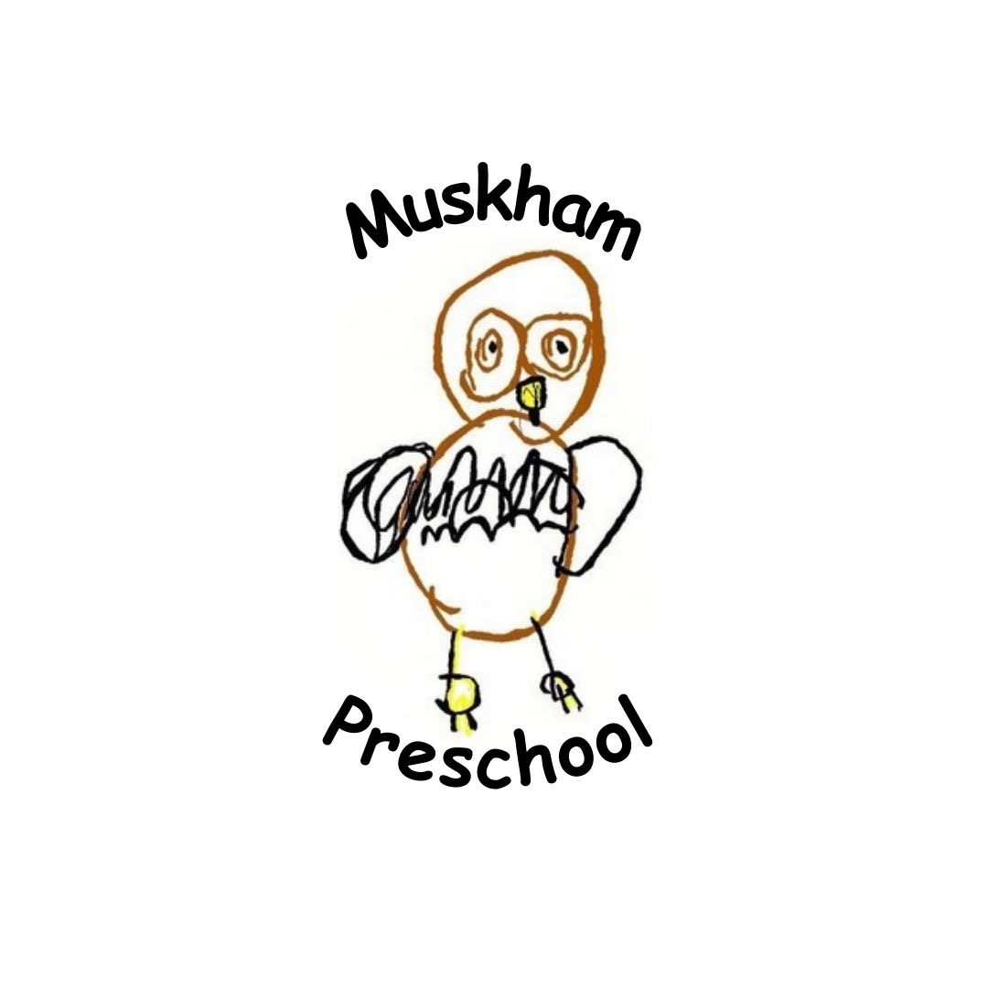

Dear Parents and Guardians,
This letter is to inform you about our use of Tapestry Online Learning Journal in our setting.
Tapestry allows us to make observations for your children where we can attach photos and videos, as well as include assessments which we can use to track children’s development and progress.
On Tapestry, parents/guardians and other relatives can view, like and comment on the observations we make for your child/ren. You can also add your own observations of what your child does outside of the setting.
We will be using the Accidents function to record accident forms for your child/ren. There is also a comments tool which we can use to send messages back and forth between you and us.
Tapestry also has a Documents feature that we use to upload documents to share with you, such as our policies and protocols.
Similarly, we will be using the Memos feature to share news and updates about your child/ren with you.
The Activities feature will be used to set home learning activities, including instructions and relevant media. Once the set activity has been completed by your child/ren, you can send it back to us through an observation.
You can also be notified via email either immediately, daily or weekly if there are new entries for you to view.
If you give your permission, we will set you up with your own individual account using your email address. This account will be directly linked to your child/ren’s account/s, which means you will only be able to see observations that include your child. You will then be able to login with your email address and password to either the browser version of Tapestry (tapestryjournal.com) or to the app. Tapestry has apps for iOS, Android and Amazon Fire devices. If you choose to use the app, after you login initially, you can use a 4-digit PIN to quickly log back in.
Tapestry securely stores all the data we input to our account on their servers. If you want to find out more information about how Tapestry keeps our data safe and secure, you just need to go to https://tapestry.info/security.html.
Please fill in the slip below with your child’s name and your email address and then sign.
Many Thanks

The e-mail address I would like to link with the account is:

I give permission for a Tapestry account to be created for me (please sign and date):
Signature: Date:

