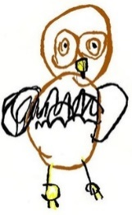North Muskham Preschool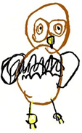
All About Me
These people are special to me:

I feel happy when:

I sometimes get upset when:

This is me
These are some of the amazing things I can do:

I like to play:

These are some of my favourite things:

My name is:

When I get upset, this helps Sometimes I find these things tricky: Things I would also like you to know:

